Lib space (a robust backend for library operations)


Team members:
- Mohanapriya s(tl)
- Nandhini s
- Nivetha s
- Padmapriya s
- Pavithra m
Introduction
Library management systems help organize and maintain book records, user information, and borrowing activities efficiently. Traditional manual library systems are time-consuming and prone to errors. To overcome these issues, digital systems are used to automate library operations.
Lib Space is a micro web-based backend system designed to demonstrate secure user authentication and book management using REST APIs. The system allows users to register, log in, manage books, and securely interact with the backend services.
The main objective of this project is to demonstrate how backend technologies, authentication mechanisms, and database integration work together in a structured application.

Project overview
Lib Space is a backend API designed for managing library operations. It
provides functionality for user authentication and book CRUD operations.
The system allows users to:
- Register a new account
- Log in securely
- Add books
- View all books
- Retrieve book details by ID
- Update book information
- Delete books
- Log out securely
- Delete their account permanently

Pre-requisites
Before running or developing Lib Space, ensure the following knowledge of:
  - JavaScript
  - Backend concepts (e.g., Node.js / Express)
  - Database fundamentals (CRUD operations)
Software Requirements:
  - Node.js and npm installed
  - Database setup (MongoDB / MySQL)
  - Code editor (e.g., VS Code)
  - Web browser (Chrome/Firefox)
Basic understanding of:
  - REST APIs
  - Authentication (sessions or JWT)
  - Environment variables
Project Objectives
The main objectives of the Lib Space project are:
- To implement a secure authentication system
- To demonstrate CRUD operations using REST APIs
- To design a structured backend architecture
- To integrate MongoDB database with Node.js
- To understand JWT-based authentication
- To implement user–book relationship management
Technical Architecture
Lib Space follows a Layered Backend Architecture consisting of:
- API Layer (Routes)
- Business Logic Layer (Controllers)
- Data Access Layer (Models / Database)
This structure ensures clean code organization, scalability, and maintainability.
1. API Layer (Routes):
The API layer handles incoming HTTP requests and defines application endpoints.
- Built using: Node.js + Express.js
- Responsible for:
- Defining routes (e.g., /register, /login, /books)
- Mapping routes to controllers
- Handling HTTP methods (GET, POST, PUT, DELETE)
- Applying middleware (authentication, validation)
Example Endpoints:
- POST → Register User
- POST → Login User
- DELETE → Delete User
- POST → Add Book
- GET → Fetch Books
- PUT → Update Book
- DELETE → Delete Book

2. Business Logic Layer (Controllers):
The controller layer contains the core application logic.
Responsibilities:
- Processing user registration and login
- Password hashing (e.g., bcrypt)
- Token generation (JWT) / session handling
- Implementing CRUD operations for books
- Validating request data
- Handling errors and sending responses
This layer acts as a bridge between routes and database.
3. Data Access Layer (Models / Database):
The data layer manages persistent storage.
- Database: MongoDB / MySQL
- Models define schema structure for:
  - Users (username, email, password)
  - Books (title, author, published date, etc.)
Responsibilities:
- Executing database queries
- Storing and retrieving data
- Maintaining data integrity

4.Request Flow:
- Client sends HTTP request to API endpoint.
- Route receives the request and forwards it to the controller.
- Controller processes business logic.
- Controller interacts with the database via models.
- Database returns data to controller.
- Controller sends structured JSON response back to client.

ER Diagram:

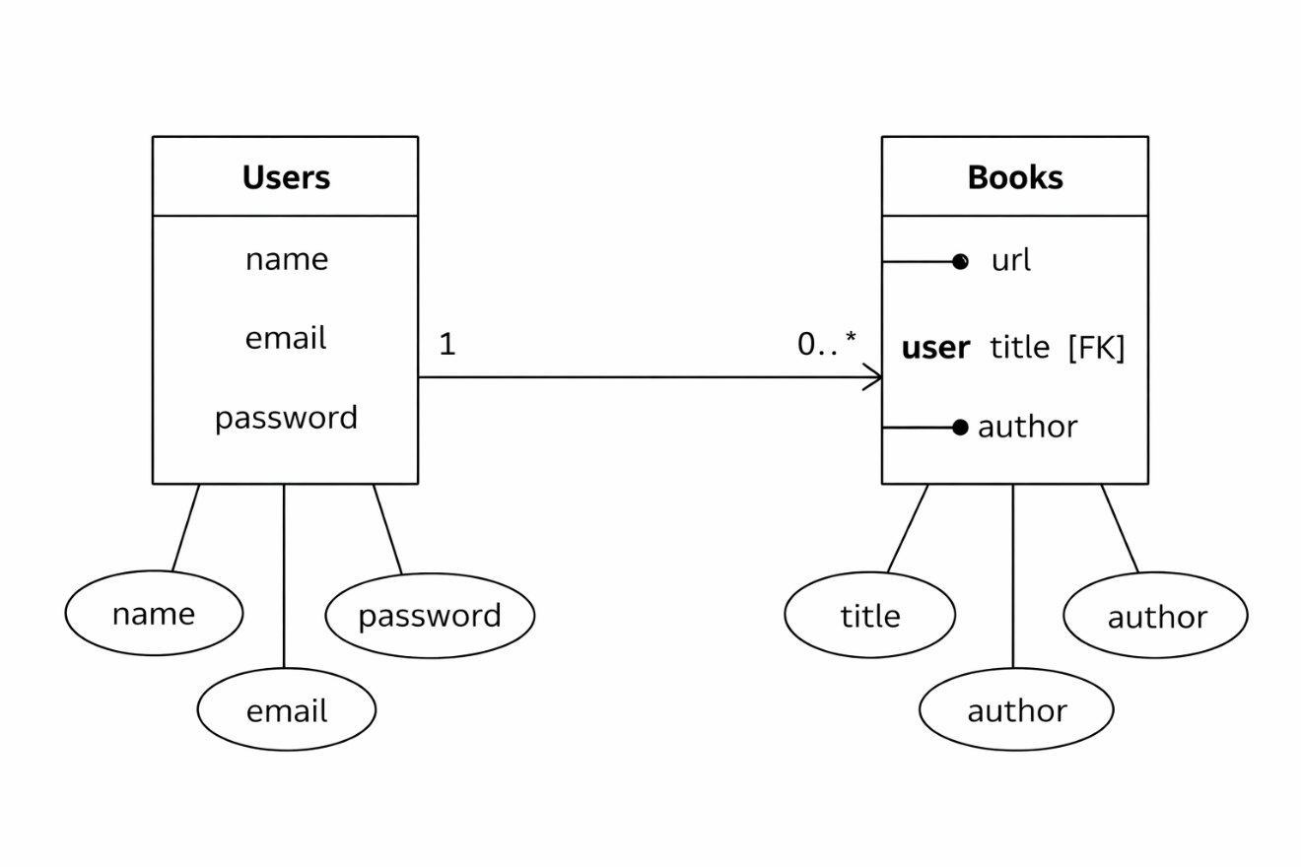

User Flow – Lib Space Backend
The user flow describes how a user interacts with the system APIs step-by-step.
User Registration
- User sends a POST request to /api/auth/register
- System validates input fields (name, email, password)
- Password is hashed using bcrypt
- User data is stored in the database
- Success response is returned

User Login
- User sends a POST request to /api/auth/login
- System verifies email and password
- If valid, a JWT token is generated
- Token is sent back in the response
- User is now authenticated

Access Protected Routes
User sends requests with:
Authorization: Bearer <token>
- Middleware verifies JWT
- If valid → request proceeds
- If invalid → access denied
Book Operations (After Login)
Authenticated user can:
- ➕ Add Book → POST /api/book/add
- 📖 Get Books → GET /api/book
- ✏ Update Book → PUT /api/book/:id
- ❌ Delete Book → DELETE /api/book/:id

Logout
- User sends request to /api/auth/logout
- Token is stored in blacklist
- User session becomes invalid

Delete User (Optional)
- User sends DELETE request with user Id
- Account is removed from database

Backend Development

The backend of Lip Space is developed using Node.js and Express.js, following RESTful architecture principles. It handles authentication, business logic, database operations, and API responses. The backend ensures secure data handling, structured routing, and efficient communication with MongoDB

API Development & Routing

The backend APIs are built using Express.js. Routes are structured into separate files for user and book operations to maintain modularity.

User Routes handle:
- Registration
- Login
- Logout

- Delete User

Advantages of lib space

- Easy Book Management
Lib space helps to store and manage all library books in one digital system. Librarians can easily add, update, or remove books.
- Quick Book Search
Students can quickly search for books by title, author, or category instead of checking shelves manually. Borrowing and returning books becomes faster because everything is recorded automatically.
- Student Record Management
The system keeps details of students who borrowed books, making tracking easy.
- Avoids Book Loss
Lib space tracks issued and returned books, which reduces the chances of losing books.
- Digital Library System
It converts the traditional library into a modern digital system that is easy to use.

Disadvantages of Lib Space

- Internet Dependency
The system needs internet or network connection. If the network fails, the library system may not work properly.
- Technical Issues
Software bugs or system errors can affect the smooth working of the library management system.
- Training Required
Librarians and staff may need basic computer training to use the system effectively.
- Data Security Risk
If the system is not properly secured, there is a risk of data loss or unauthorized access.
- Initial Setup Cost
Setting up the system (computers, software, maintenance) may require some investment.
- System Maintenance
Regular updates and maintenance are needed to keep the system working properly.

Technologies Used in Lib Space
- HTML
Used to create the structure of the website pages like login page, book list, and dashboard.
- CSS
Used to design and style the webpages to make the system look neat and user-friendly.
- JavaScript
Used to add interactivity, such as searching books, form validation, and button actions.
- Node.js
Used for the backend to handle server operations and process user requests.
- Express.js
A framework used with Node.js to build the backend and manage routes easily.
- MongoDB / Database
Used to store data such as book details, student details, and issue/return records.
- Git & GitHub
Used for version control and storing the project code online.
Future Scope of Lib Space
- Online Book Reservation
Students can reserve books online before visiting the library.
- Mobile Application
A mobile app can be developed so students can access the library system from their phones.
- E-Book Integration
Digital books (PDF / e-books) can be added so students can read online.
- Automated Notifications
The system can send reminders to students about book return dates through email or SMS.
- Barcode / QR Code System
Books can be issued and returned faster using barcode or QR code scanning.
- Advanced Search System
Users can search books by category, author, year, or availability.
- Multi-Library Support
The system can be expanded to manage multiple libraries in schools or college
Reduces Paper Usage

Future Scope

Lib space stores book records, student details, and issue/return information digitally, so less paper is required.
- Eco-Friendly System
By using a digital platform, the library helps protect the environment and supports a green initiative.
- Less Physical Storage
Digital records reduce the need for large cupboards and files to store paper documents.
- Energy Efficient Management
Managing records digitally saves time and resources compared to manual systems.
- Promotes Digital Learning
The system encourages students to use digital resources like e-books instead of printed materials.

CONCULSION
Lib space is a smart and efficient library management system that helps manage library activities digitally. It makes book searching, issuing, and returning easier and faster for both students and librarians. The system stores all records safely and reduces manual work. By using modern technologies, Lib space improves library management and supports digital learning in educational institutions. Overall, it makes the library system more organized, reliable, and user-friendly. Lib Space is a useful library management system that helps manage books and users easily. It simplifies tasks such as adding books, registering users, borrowing books, and returning books. By using technologies like Node.js, Express, and a database, the system stores and manages information efficiently.

THANK YOU..

